
TDH MANAGER
Development Notes
June 19, 2025
The data ANalysisd Hub ltd
1 The Courtyard, 707 Warwick Road, Solihull. B91 3DA

Published by
Lee Stevens
22 Hollyhedge Road
West Bromwich
West Midlands
B71 3AA

Copyright © 2021-2025 by Lee Stevens and The Data Analysis Hub Ltd

No part of this publication may be reproduced, stored in a retrieval system or transmitted in any form or by any means, electronic, mechanical, photocopying, recording, scanning or otherwise, without either the prior written permission of the Publisher.

Requests to the Publisher for permission should be sent to the above address.

Limit of Liability and Disclaimer of Warranty
The publisher and the author make no representations or warranties with respect to the accuracy or completeness of the contents of this work and specifically disclaim all warranties, including without limitation warranties of fitness for a particular purpose. No warranty may be created or extended by sales or promotional materials. This work is published with the understanding that the publisher is not engaged in rendering legal, accounting, or other professional services. If professional assistance is required, the services of a competent professional person should be sought. Neither the publisher nor the author shall be liable for damages arising therefrom. The fact that an organisation or Web site is referred to in this work as a citation or a potential source of further information does not mean that the author or the publisher endorses the information the organisation or website may provide or recommendations it may make.

LEGAL NOTICES 4
Copyright and Licensing 4
Disclaimer 4
OVERVIEW 5
Project Summary 5
Goals 5
Version Control 5
Features 5
DATABASE SCHEMA 0
Tables Summary 0
User Accounts and Logging in 1

LEGAL NOTICES

Copyright and Licensing
The software is written on the basis that copyright for all design, code and intellectual property remains with Lee Stevens and The Data Analysis Hub Ltd. “Design” includes the contents of this document.

The web application is covered by UK and worldwide copyright laws and access to the application is licensed, not sold. The licence will apply to the software and any future updates and supplements to the software unless further licence terms accompany the updates or supplements.

By accessing the web portal you are deemed to have accepted these terms. If you do not accept them, do not access the portal.

Disclaimer
No liability for the contents of this publication can be accepted. Use the concepts, examples and other content at your own risk. There may be errors or inaccuracies which have not yet been noted. The author does not take any responsibility for errors, inaccuracies or omissions whether or not previously reported.

Use of a term in this document should not be regarded as affecting the validity of any trademark.

Naming of particular products or brands should not be seen as endorsements.

OVERVIEW

Project Summary
TDH Manager is a multi-purpose management database provided for The Data Analysis Hub Ltd, encompassing customer, supplier, camera, footage, health check scheduling, vehicle and incident management.

Software and Languages
The project is a web application, i.e. can be accessed using a web browser and not installed on a local machine.
The project is written using HTML, CSS, Javascript and PHP. Third party libraries, frameworks and plug-ins used are Bootstrap, Bootstrap Datatables, Bootstrap Icons, JQuery, JQuery UI and Popper, SweetAlert and Select2. Fontsare from Google Fonts. All references to the above are by CDN in index.php or

Goals
- Provide a customer management system
- Provide a method to manage extant camera and tracker devices
- Provide a central repository for customer, insurer and broker notes
- Provide an alert or reminder system of insurance renewals, scheduled installs & general notes
- Provide a central repository for incident footage management.
- Allow job and task scheduling and tracking
- Help to remove or reduce the number of spreadsheets currently used to manage the day to day running of the company

Version Control
The version number of each release will consist of three separate sections delimited by a period or full stop, e.g. 'a.b.c'

Major Version (a) Major software release number. This number will only be incremented upon major redesign of the project’s GUI or database, or if more than five major new features have been implemented.

Minor Version (b) Minor software revision number. This number will be incremented when minor new features are implemented or less than five major new features have been implemented. This revision number will be one digit, incrementing above nine will increase the major version number irrespective of revision type.

Patch Number (c) Updates and bug fixes or patches revision number. This number will be incremented upon each new release which does not warrant a minor version number increase and will be mainly for minor updates to existing features and/or bug fixes. This revision number will be two digits, incrementing above ninety nine will increase the minor version number.

Features

Access Control
- Individual access control linked to email address and password
- Individual access levels, e.g. installer, standard, administrator
- Password reset option from log-in

Customers
Record the following information:
- Customer name and general contact details
- Contact details for any number of customer individual employees
- Insurance and insurer details and individual insurer contact details
- Broker details and individual broker contact details
- Customer notes
- Renewal details
- Footage request details
- Customer devices
- Customer vehicles
- Job requests for customer
Devices
Record the following information:
- Device owner
- Vehicle registration
- Type of device and platform
- Serial number
- IMEI
- DRID number
- Configuration details
- Current status
- SIM Number
- SIM Phone number
- Deactivation date if any
- SIM / Device status
- Original installer
- Installation date

DATABASE SCHEMA
The live database is hosted on MS Azure and can be accessed using MySQL Workbench or other MySQL admin tool.

Tables Summary

Table Name | Description
tblBroker | Broker Details
tblBrokerContact | Broker Contacts
tblBrokerNote | Broker Notes
tblCustomer | Customer Details
tblCustomerContact | Customer Contacts
tblCustomerNote | Customer Notes
tblDevice | Device/Camera Details
tblDeviceDescription | Stock description, e.g. CP2, CP4
tblDeviceStatus | Status description e.g. installed, with installer
tblEventLog | Event log
tblFootageFiles | Footage file paths
tblFootageRecipient | Footage recipient log
tblFootageRequest | Footage Request Details
tblFootageStatus | Status of footage requests, e.g. complete, investigating.
tblForgotPassword | Forgotten password requests
tblGlobals | Global settings
tblHealthcheck | Device healthcheck log
tblHealthStatus | Health check descriptions
tblInstaller | Installation company details
tblInstallerContact | Installation company contacts
tblInsurer | Insurance company details
tblInsurerContact | Insurance company contacts
tblInvites | Invitations to register for login
tblIssue | Bug/TODO list – now obsolete
tblJobRates | Job cost matrix by device and job type
tblJobs | Installs, service calls list
tblJobType | Descriptions of job types
tblOther | Other business partners
tblOtherContact | Contacts of other business partners
tblPlatform | Platform descriptions
tblRenewalType | Renewal types
tblSIMStatus | SIM Card Status descriptions
tblSupplier | Hardware supplier details
tblSupplierContact | Supplier contacts
tblUserRecord | Registered user information
tblUsers | Registered users – login credentials
tblVehicle | Vehicle details

Connecting to the database
The database is a MySQL database, currently hosted on MS Azure. Database credentials are:
Hostname: tdhdbserver.mysql.database.azure.com
Username: tdh_superuser@tdhdbserver
Password:
Database name: TDHManager

The connection to the database is established using PHP with the following code which provides a $link variable, which can then be accessed in each PHP script by including the connect.php file.
connect.php
<?php
$link = mysqli_connect('tdhdbserver.mysql.database.azure.com', 'tdh_superuser@tdhdbserver',***password*** 'W1!!14m%t3v3n5', 'TDHManager');
if (mysqli_connect_error()) {
die("Database is unavailable - " . mysqli_connect_error());
}

User Accounts and Logging in
New user invitation
To log in, you will need to have received an invitation to register. The invitation to register must be initiated by a current admin user.
The process for setting up a new user and allowing access is:
- An admin user sends an invite to the prospective new user
- Prospective user receives an email and follows link
- Prospective user completes sign up form to register their account
- Prospective user receives link in email to activate account
- Account is activated
- User can login
To invite a new user, an administrator user must already be logged in. The admin user will have access to the Admin ⇒ Settings screen. On this screen you will see a list of current users:

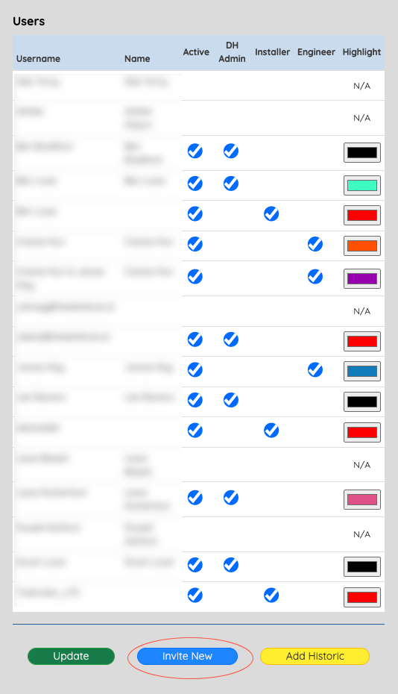
The blue ‘Invite New’ button has an
id = ‘inviteNewUser’ and is defined in globalsettings.php

The click event for this button is listened for in clickEvents.js by the JQuery listener below and the callback is a function which shows a modal dialog box to collect the email address of the new user and their user type.
$(document).on("click", "#inviteNewUser", function (event){
event.preventDefault();
$("#modalGetNewUserEmail").modal("show");
});
Clicking the button will show the Bootstrap modal dialog box
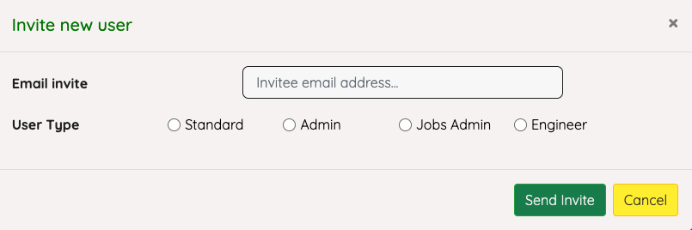
The dialog’s definition is in php/modals/modal_UserEmail_get.php and is detailed below (not all dialog’s will be detailed like this in the document for the sake of brevity and space).
<!-- GET NEW USER EMAIL ADDRESS -->
<div class="modal" id="modalGetNewUserEmail" data-backdrop='static'>
<div class="modal-dialog" style='max-width:50%'>
<div class="modal-content">
<div class="modal-header">
<h5 class="modal-title" style='color:green'>Invite new user</h5>
<button type="button" class="close" data-dismiss="modal">
&times;
</button>
</div>
<div class="modal-body">
<form method='POST' id='getNewUserEmail' class='getNewUserEmail
form-block'>
<div class='form-group'>
<div class='row'>
<div class='col-sm-4 col-md-4'>
<label class='control-label inline'
for='newUserEmailAddress' style='padding-top:8px;'>
<strong>Email invite</strong>
</label>
</div>
<div class='col-sm-8 col-md-6'>
<div class='input-group'>
<input class='form-control' type='email'
placeholder="Invitee email address..."
name='newUserEmailAddress' id='newUserEmailAddress'>
</div>
</div>
</div>
<div class='row'>
<div class='col-3'>
<label for='userLogInStandard' class='control-label inline'
style='padding-top:16px;'>
<strong>User Type</strong>
</label>
</div>
<div class='col-2' style='margin-top:16px'>
<input type='radio' class='form-check-input'
id='userLogInStandard' name='userType'>Standard
</div>
<div class='col-2' style='margin-top:16px'>
<input type='radio' class='form-check-input'
id='userLogInAdmin' name='userType'>Admin
</div>
<div class='col-2' style='margin-top:16px'>
<input type='radio' class='form-check-input'
id='userLogInInstaller' name='userType'>Jobs Admin
</div>
<div class='col-2' style='margin-top:16px'>
<input type='radio' class='form-check-input'
id='userLogInEngineer' name='userType'>Engineer
</div>
</div>
</div>
<div id='newUserEmailMessage'></div>
</form>
</div>
<div class="modal-footer">
<button type="button" id='inviteNewUserEmail' class="btn btn-
success">Send Invite</button>
<button type="button" class="btn btn-warning" data-
dismiss="modal">Cancel</button>
</div>
</div>
</div>
</div>
The yellow cancel button simply dismisses the dialog.
The green ‘Send Invite’ button (id='inviteNewUserEmail') is listened to by the JQuery listener below, which will send the information from the dialog to be checked and if all is complete, to send an email to invite the new user.

$(document).on("click", "#inviteNewUserEmail", function (event) {
event.preventDefault();
dataToPost = {};
dataToPost.newUserEmail = $("#newUserEmailAddress").val();
dataToPost.userTypeStandard = $("#userLogInStandard:checked").val();
dataToPost.userTypeAdmin = $("#userLogInAdmin:checked").val();
dataToPost.userTypeInstaller = $("#userLogInInstaller:checked").val();
dataToPost.userTypeEngineer = $("#userLogInEngineer:checked").val();
$.ajax({
url: "inviteNewUser.php",
type: "POST",
data: dataToPost,
success: function (data) {
if (data.includes("An invitation email has been sent to")) {
$("#modalGetNewUserEmail").modal("hide");
$("#userErrorBox").html(data);
$("#userErrorBox").delay(2500).hide(0);
} else {
$("#newUserEmailMessage").html(data);
}
},
error: function () {},
});
});
This event handler

